**CodaLab**

**Making a Submission and Viewing Results**

To make a submission to the ML Hackathon contest, this involves uploading a zip file containing files with your answer, in the format that has been specified by the ML Hackathon.

**Steps to make a submission**

1. **Go to** the CodaLab ML Hackathon contest at: <http://codalabtest.cloudapp.net/competitions/742>
2. **Sign in** using your newly acquired credentials: team name and password.

You will see the **Participate** tab, such as illustrated below:

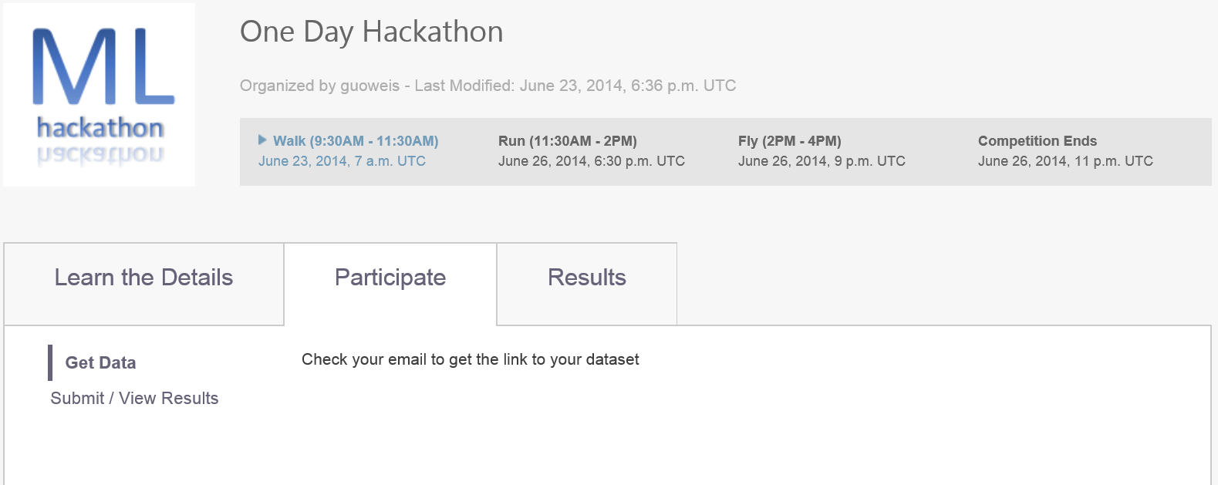

**NOTE THAT THE LINK TO YOUR DATASET WILL BE SENT TO YOU VIA EMAIL, SO CHECK YOUR EMAIL!**

1. **Submit Results**, when you are ready to submit your results, following steps a) to c) below:

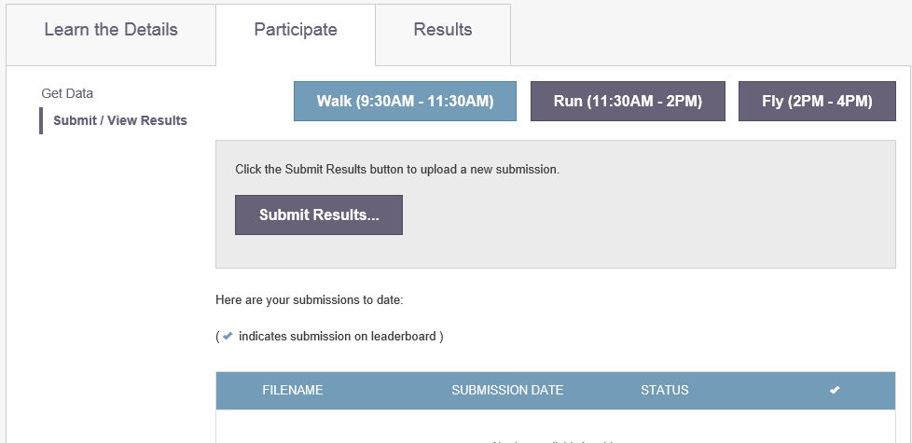

On this page you can make new submissions, and see previous submissions for each phase in the competition

1. To **Submit Results,** you will be prompted to select a submission zip file. Locate the file you want to submit and click **Open** to upload your submission. When uploading is complete the details will be displayed, as illustrated below:

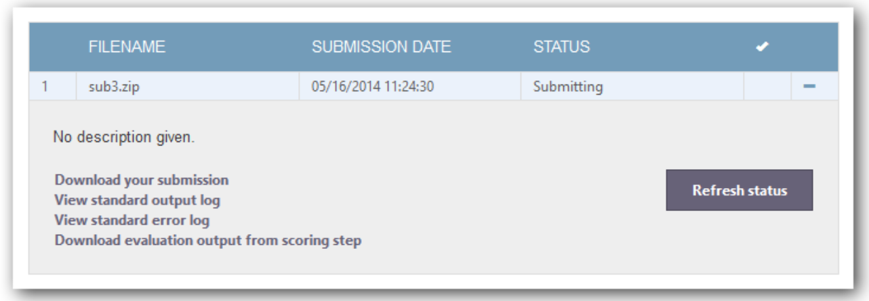

The detail page for each submission includes links to download the submission file, view standard output and error logs, and download evaluation output.

1. Click **Refresh status**, to update the status of your submissions
   1. If there is an error with your submission, you can use the standard output and error logs to get more information
   2. If your submission finishes successfully, the **Status** will show as “**Finished**”
2. **Click Submit to Leaderboard**

**IMPORTANT:** Your submission will not be active until you submit it to the leaderboard.

If you want remove a submission, you can do so by clicking **Remove from Leaderboard**.

**Viewing results**

You can keep up with the progress of competitions you are participating in, by visiting the competition results page at: <http://codalabtest.cloudapp.net/competitions/742#results>

